System 20™ is an easy-to-use, quality designed, and economical coating that provides good gloss. System 20™ has fast dry times and good coverage – an excellent choice when a quality economical finish is needed.
System 20™ Synthetic Enamel Color System

Product Cross Reference Information
Product comparisons are based on a similar product replacement. Performance and mix ratios may vary.
DuPont | PPG | SW | BASF
Dulux® | Ditzco® | Kem Transport | Limco

DIRECTIONS FOR USE
Application recommendations are for an ambient shop temperature of 75°F. Temperature and humidity will affect dry times.

MIX BY VOLUME (8:1:2)
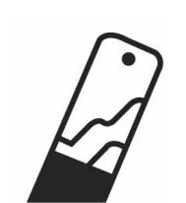
Combine components by volume, mix thoroughly, and strain before spraying.
See Product Information Sheet #1032 for full usage details.

8 Parts System 20™ Color
1 Part MP2000™ Catalyst
2 Parts TH5000™ Series Reducer

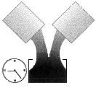
POT LIFE

4 – 6 hours at 75°F

ADDITIVES
Accelerator: If needed, use 1 – 2 ounces of CR22ACC™ Accelerator per ready-to-spray gallon (or ¼ - ½ ounce per ready-to-spray quart). Note: System 20™ must be catalyzed in order for accelerator to be effective.

Fish Eye Eliminator: If needed, add 1-2 ounces of CR22FEE™ per ready-to-spray gallon (or ¼ - ½ ounce per ready-to-spray quart). Note: Only use Montana CR22FEE™ Fisheye Eliminator. Other brands may be incompatible.

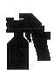
GUN SETUP
Fluid Tip Air Pressure
HVLP Gravity: 1.3 – 1.6mm 6 – 10 PSI at the cap
HVLP Siphon: 1.3 – 1.8mm 6 – 10 PSI at the cap
Conventional Gravity: 1.3 – 1.6mm 45 – 55 PSI at the gun
Conventional Siphon: 1.3 – 1.8mm 45 – 55 PSI at the gun

APPLICATION (As an overall or full-panel repair)
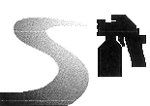
- Allow appropriate dry times of primers and sealers.
- Confirm color match is appropriate by testing color prior to application.
- Strain paint prior to application.
- Apply one medium wet coat and allow 15 – 20 minutes flash or until surface is hand slick.
- Apply a 2nd full wet coat.
- If a 3rd coat is needed, allow 20-minutes flash between 2nd and 3rd coats. For best results, do not apply more than 3 coats.
- If metallics are being applied, apply one fog coat immediately after last coat, holding the spray gun back an additional 2 – 3”. Raising the air pressure a few pounds will help even out metallics.
- See Product Information Sheet #1032 for full usage details.

COMPOUNDING/POLISHING
- Air Dry: 24 – 36 hours at 75°F.
- See Product Information Sheet #1032 for full usage details.

PHYSICAL DATA
Dust Free: 30-minutes MSDS #12 (No Lead), #13 (Leaded)
Dry to Handle: Overnight Activator MSDS #6
VOC: 5.0 lbs/gal (maximum) Reducer MSDS #1
P.I.S. #1032

Read and follow all technical product information, labels, and MSDS prior to application. Keep product out of reach of children and animals. Always wear proper safety equipment (respirator, gloves, eye, and clothing protection) when using this product.
Rev. 6/16/05
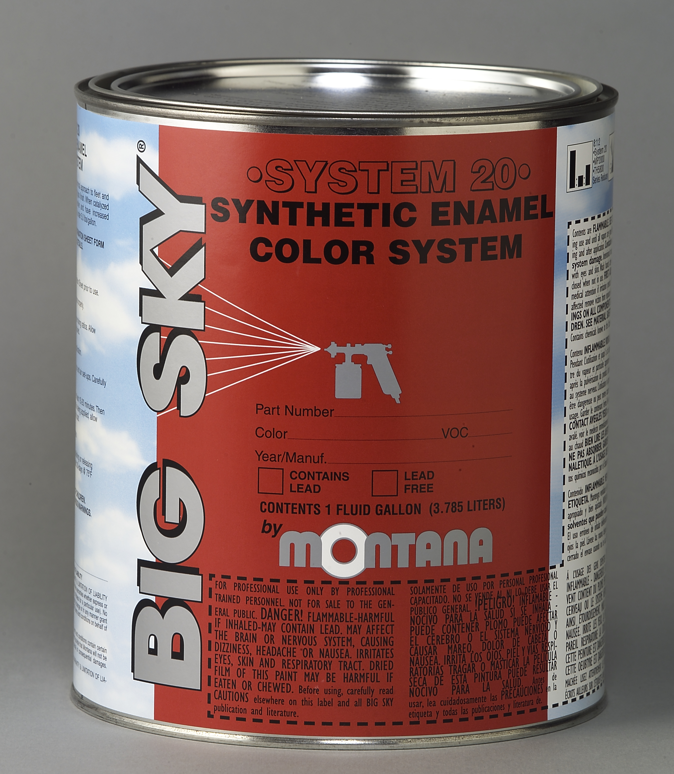


System 20™ Sell Sheet
Form #9020
DESCRIPTION
ADVANTAGES
BIG SKY
BIG SKY
®
Phone: (800) 328-4892 ● Fax: (330) 669-3965
9287 Smucker Road ● Orrville, OH ● 44667
Website: www.chemspec.co.za
www.montanabigsky.com
System 20™ is an easy-to-use, quality designed, and economical coating that provides good gloss. System 20™ has fast dry times and good coverage – an excellent choice when a quality economical finish is needed.
Fast Dry Times. Economical. Good Gloss.
- Easy-To-Use
- Economical
- Good Gloss
- Excellent Coverage
- Provides a Quality Finish
SYSTEM 20™
SYNTHETIC ENAMEL COLOR SYSTEM

